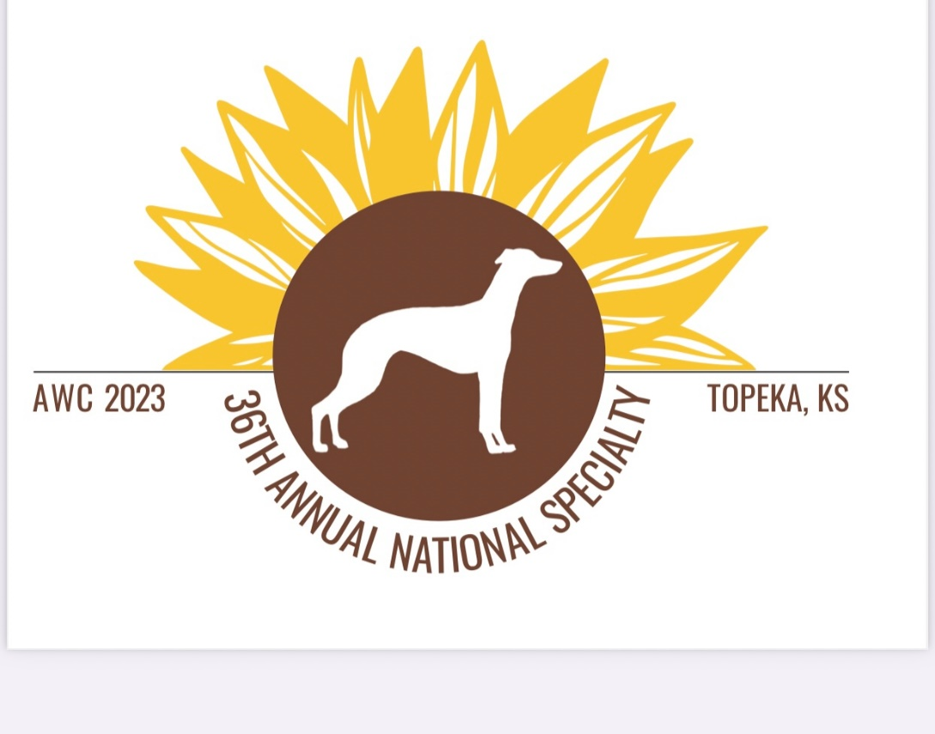
2023 AWC National Specialty
Fine Art Exhibition
April 10th through April 15th 2023

CALL FOR ENTRIES
The Fine Art Exhibition from April 10th-15th, 2023 will be held at the Hotel Topeka at City Center 1 717 SW Topeka Boulevard, Topeka, Kansas 66612
The exhibition is free and open to the public. It will be juried by local artist(s) and a member of our whippet community. Artists may enter as AWC members or as whippet fanciers.
General Information:

- The piece(s) must be created within the last five years and not displayed at a previous AWC Competition.
- The piece(s) must be an original created by the artist and submitted by the artist. In the event that the piece is being submitted on behalf of a family member a signed release must accompany the work.
- Submission deadline for all works is March 27th 2023.
- Piece(s) must be delivered to the National in Topeka no later than Monday April 10th and be picked in the event they did not sell by the completion of breed judging on Saturday April 15th 2023.
- The show will be juried and pieces will be placed one through three in each class. First place winners in each class will go on to compete for “Best In Show”. All pieces will be eligible for “People’s Choice Award”.
- An artist may submit up to five pieces (total) in any class including multiple pieces in one class.
- Artists are encouraged to look for inspiration featuring the beautiful life of whippets as they create.
- Pieces may be offered for sale at the artist’s discretion with 25% of the sale price being donated to the AWC.
- If an entry sells, the artist will be contacted. Entries should remain on display until the exhibit’s close. While the exhibition will be locked at night, AWC
is not responsible for any theft or damage to artwork.

Classes will be offered in both amateur and professional divisions:

- Painting (oil, acrylic, water color)
- Drawing
- Textiles (sewing, quilting, knitting)
- Sculpture (bronze, clay, felted)
- Glasswork/woodwork
- Photography
- Mixed media
- Miscellaneous

All works must be ready to be displayed, framed or unframed and no larger than 24” x 36”. In the event that you will be submitting sculptures or pieces requiring table display please contact the committee members EARLY so we can ensure adequate display space is available.

Submission fees:
- 1-2 pieces $25 per work
- 3 pieces $60
- 4 pieces $80
- 5 pieces $90

Please see the National website for submission forms.

Cheers,

The AWC National Art Committee

Destinie Stapleton, Caroline Cope Wells & Carolyn Maskens

