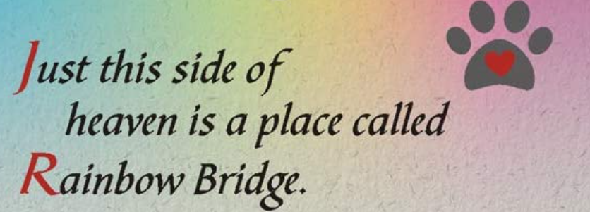

Please pay tribute to those very special whippets and whippet fanciers who have passed on to the rainbow bridge at the next AWC 2023 Rainbow Bridge Memorial Table.
In order to meet the necessary timelines, please send in your entries with the following information noted below to alicevand@usa.net:

Whippets: Full Registered Name, Call Name, Titles Earned, Date of Birth, Date Passed and Name of Owner (s).
Fancier: Full Name, Kennel name, Date of Passing and any notes or special memories.

Each entry should have an 8 x 10 framed print brought to the national to be displayed on the Rainbow Bridge table. After the national, these will need to be picked up as they will not be shipped back to the owner.
Donations are appreciated and checks can be made payable to: AWC to the below address:
Alice VandenBussche
12591, Old Rt 31
Savannah, NY 13146
alicevand@usa.net

Please do not miss the deadline: MARCH 1, 2023

